Report
Of
NetSage AI: An AI-Assisted Troubleshooting Helper for
Packet Tracer Lab Problems with Human-in-the-Loop Review
Submitted
To
School of Computer Science and Engineering
IILM University, Greater Noida, U.P.
In partial fulfilment of the requirement of degree of
B.Tech CSE

By
Roll Number of Student: 2410030934
Name of Student: SAMARTH MEHROTRA
Batch: 2024-28
CANDIDATE'S DECLARATION
I, Samarth Mehrotra, do hereby declare that the internship report titled “NetSage AI: An AI-Assisted Troubleshooting Helper for Packet Tracer Lab Problems with Human-in-the-Loop Review” has been completed by me to fulfil the requirement for the award of the degree of Bachelor of Technology in CSE. All the references have been quoted and I have not taken as such any material from any other source. I affirm to you that this report is my own and has not been submitted to any other institute for any degree/diploma requirement and further I shall be solely responsible for any kind of copyright violation in this regard.

Signature : Samarth Mehrotra
Student Name: Samarth Mehrotra
Roll No.: 2410030934

ACKNOWLEDGEMENT
I am using this opportunity to express my gratitude to everyone who supported me throughout the Cisco–AICTE Virtual Internship Program. I am thankful for their aspiring guidance, invaluably constructive criticism and friendly advice during this work. I am sincerely grateful to the Cisco program mentors and to Dr. Swati Vashisht, SPOC–Cisco VIP 2026, IILM University, for coordinating the program and for her continuous support throughout its duration. I am sincerely grateful to them for sharing their truthful and illuminating views on a number of issues related to this work.
I express my gratitude to my parents for their blessings.

Signature: Samarth Mehrotra
Student Name: Samarth Mehrotra
Roll No.: 2410030934

TABLE OF CONTENTS
Chapter No. | Chapter Name
 | Cover Page | -----
1. | Candidate's Declaration | i
2. | Acknowledgment | ii
3. | Internship Completion Certificate | v
4. | Project Description | 1
 | 4.1 Introduction | 1
 | 4.2 Organization Profile | 1
 | 4.3 Problem Statement | 2
 | 4.4 Project Objectives | 2
 | 4.5 Scope of the Project | 2
 | 4.6 Technologies and Tools Used | 2
 | 4.7 System Architecture | 3
 | 4.8 Methodology | 3
 | 4.9 Expected Outcomes | 4
 | 4.10 Certificates of Completion and Communication Proof | 4
5. | Bibliography/References | 5

3. Internship Completion Certificate
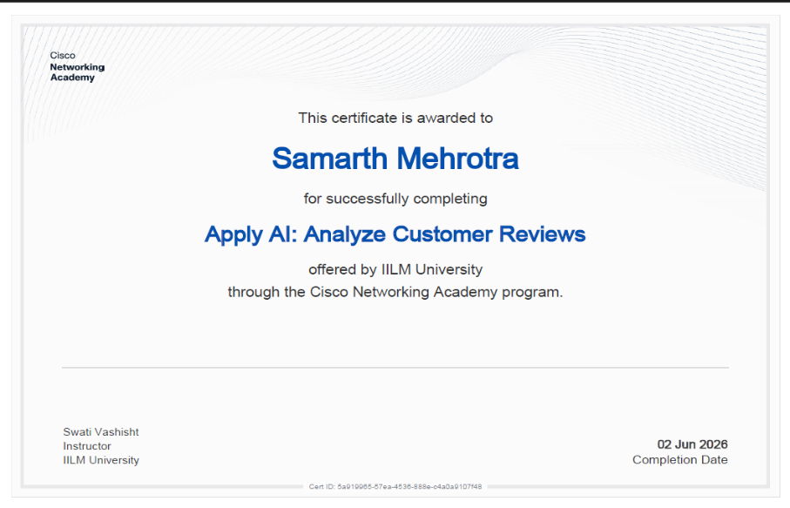
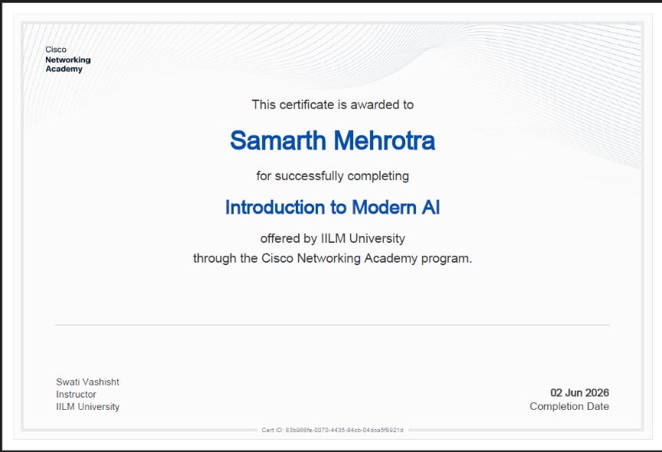
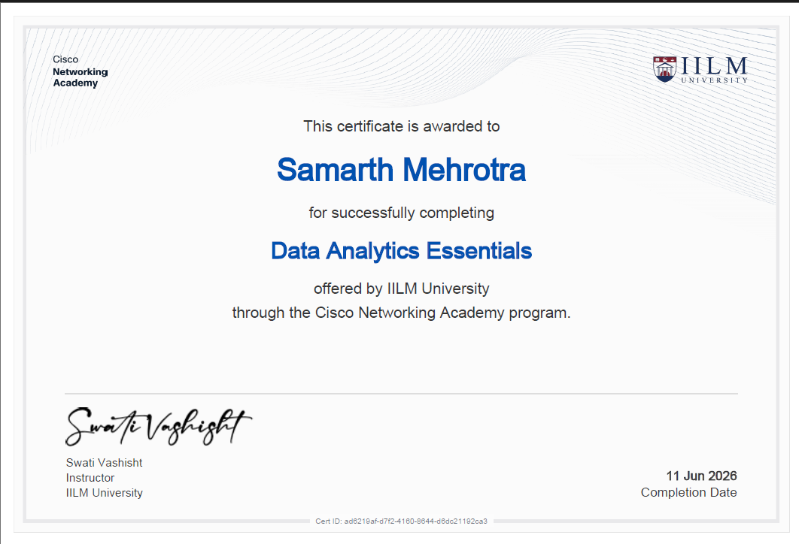

4. Project Description
4.1 Introduction
This report documents the work completed as part of the Cisco–AICTE Virtual Internship Program (VIP 2026), undertaken through IILM University, Greater Noida. The internship followed a cohort-based structure in which students were assigned a specialisation area and a corresponding problem statement to address using Cisco Packet Tracer and applied AI concepts. The assigned cohort for this report is “NetSage AI,” and the associated problem statement required building an AI troubleshooting helper for Packet Tracer lab exercises, with a human reviewer required to approve any suggested fix before it is applied. The internship began with an Industry Connect session conducted by Cisco officials, followed by cohort-specific project briefings, after which students worked independently on their assigned problem statement.
4.2 Organization Profile
Cisco Systems, Inc. is a multinational technology company specialising in networking hardware, software, and cybersecurity solutions. Through the Cisco Networking Academy, Cisco partners with academic institutions worldwide to deliver structured, industry-aligned training in networking, cybersecurity, and emerging technologies such as AI-assisted network operations. The Cisco–AICTE Virtual Internship Program extends this mission by pairing student cohorts with real-world-style problem statements that combine Cisco's networking curriculum (delivered via Packet Tracer) with modern software and AI development practices, under the guidance of Cisco officials and institutional coordinators.
4.3 Problem Statement
Students working through Cisco Packet Tracer labs frequently encounter configuration and connectivity issues — misconfigured VLANs, incorrect routing tables, ACL conflicts, interface errors, and similar faults — and often lack an immediate, structured way to diagnose them without instructor intervention. The NetSage AI problem statement asks for the design of an AI-assisted troubleshooting helper that can read a description of the symptoms a student is observing along with the output of relevant Packet Tracer show commands (e.g., show ip route, show vlan, show interface), analyse this information, and suggest the most likely causes and next diagnostic or corrective steps. Critically, the tool is required to operate on a human-in-the-loop basis: it must never apply a fix automatically, and every suggested resolution must be explicitly reviewed and approved by a human before it is considered final.
4.4 Project Objectives
- Design a system that accepts free-text symptom descriptions and raw show-command output as input.
- Use an AI/LLM-based reasoning layer to interpret the input and identify probable root causes.
- Generate a ranked list of likely causes with clear, actionable next steps for each.
- Enforce a mandatory human-review checkpoint before any suggested fix is marked as accepted or actioned.
- Maintain a log of past diagnostic sessions to support review, learning, and iteration.
- Keep the workflow lightweight enough to be usable during a live lab session.
4.5 Scope of the Project
The scope of this project covers the design and prototyping of the troubleshooting assistant's core workflow: input capture (symptoms and show-command output), AI-based analysis and suggestion generation, and a human review/approval step before any suggestion is treated as final. The project focuses on common, well-documented categories of Packet Tracer networking faults (Layer 2 switching issues, Layer 3 routing issues, and basic ACL/security misconfigurations). It does not extend to live automated remediation of the Packet Tracer topology itself — by design, the system stops at the suggestion-and-review stage rather than executing changes, consistent with the human-in-the-loop requirement of the problem statement.
4.6 Technologies and Tools Used
- Cisco Packet Tracer — for building and reproducing network topologies and generating show-command output.
- An LLM-based reasoning/analysis layer — for interpreting symptoms and show-command output and generating cause/step suggestions.
- n8n — for orchestrating the intake-to-review workflow (webhook/form intake, AI analysis step, logging, and review notification).
- A structured data store (e.g., Google Sheets/Supabase) — for logging each diagnostic session and its human-reviewed outcome.
- A simple front-end/chat interface — for submitting symptoms and command output, and for the reviewer to approve or reject suggestions.
4.7 System Architecture
The system follows a four-stage pipeline. First, an Intake stage collects the student's symptom description and any relevant show-command output through a simple form or chat interface. Second, an Analysis stage passes this input to the AI reasoning layer, which parses the command output, cross-references it against known fault patterns, and produces a ranked set of probable causes with suggested next steps. Third, a Review stage surfaces these suggestions to a human reviewer — an instructor, lab assistant, or the student themselves acting in a review capacity — who must explicitly approve, modify, or reject each suggestion; no suggestion is applied or marked complete without this step. Fourth, a Logging stage records the full session (input, AI suggestion, reviewer decision, and final outcome) for later reference, auditability, and continuous improvement of the suggestion quality.
4.8 Methodology
The project was developed iteratively. Common Packet Tracer fault scenarios were first catalogued (VLAN mismatches, routing misconfigurations, interface/administrative shutdowns, and ACL conflicts) along with the show-command output typically associated with each. This catalogue was used to shape the prompting strategy for the AI analysis layer, ensuring its suggestions stayed grounded in the actual command output rather than generic advice. The intake-to-review workflow was then built and tested end-to-end using representative sample scenarios, with particular attention paid to the mandatory human-review checkpoint so that no suggestion could bypass reviewer approval. Each test scenario was logged and reviewed to refine the accuracy and clarity of the AI's suggested causes and next steps.
4.9 Expected Outcomes
- A working prototype that can take symptom descriptions and show-command output and return ranked, plausible root causes with next steps.
- A clear, auditable human-review checkpoint that prevents any suggestion from being auto-applied.
- A session log that can be used by instructors to see common fault patterns across a cohort.
- A reduction in the time students spend stuck on routine, diagnosable Packet Tracer lab issues, while preserving instructor oversight.
4.10 Certificates of Completion and Other Communication Mail Proof
[Attach here: (1) Cisco–AICTE Virtual Internship Program completion certificate(s) — all three as required by the program coordinator, and (2) screenshots/printouts of relevant communication emails, such as the Industry Connect session registration confirmation and the final report submission acknowledgement.]

5. Bibliography/References
1. Cisco Systems, Inc. — Cisco Networking Academy, Cisco Packet Tracer Documentation. Available at: https://www.netacad.com
2. AICTE — Cisco AICTE Virtual Internship Program 2026, Programme Guidelines and Cohort Problem Statements.
3. IILM University, Greater Noida — Internal correspondence and Industry Connect Session materials, Cisco VIP 2026, Dr. Swati Vashisht (SPOC, Cisco VIP).

